**Database Design**

**Table Explanation**

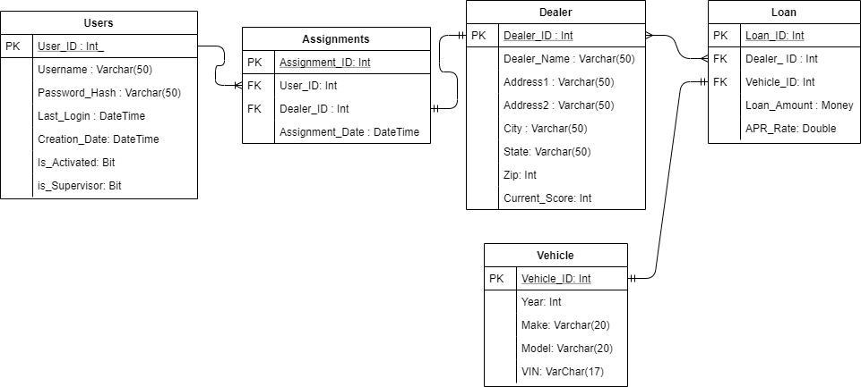

USERS: This Table will be used on the login screen in order to check which users are able to log in to the system. The table will not be storing passwords in plain text, but will store the hashes of the password. If the user is a supervisor, then the user will be able to view all of the dealerships at once. If he/she is not a supervisor, then only assigned dealerships will be shown. Each user will need a unique username.

ASSIGNMENTS: This table is used in finding which dealerships the user will be assigned to. It will relate with a user_id, and will show the corresponding dealer_id.

DEALER : This table is where the dealer information is stored. This information is used when processing a new loan.

LOAN: This table is used to store loan information and is tied to a certain vehicle in the database.

VECHICLE: All vehicles are stored in this table, and will be pulled with the loan that it is associated with. A vehicle will only be able to have one loan out in the table.

**Web Application Design**

**Login Form**

This form will allow a user to log in to either a supervisor account or an employee account.

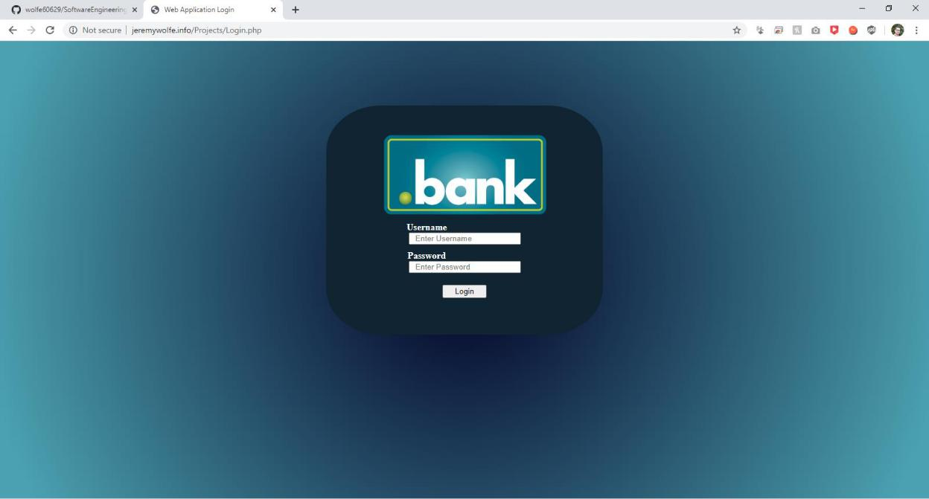

**Admin Dashboard :**

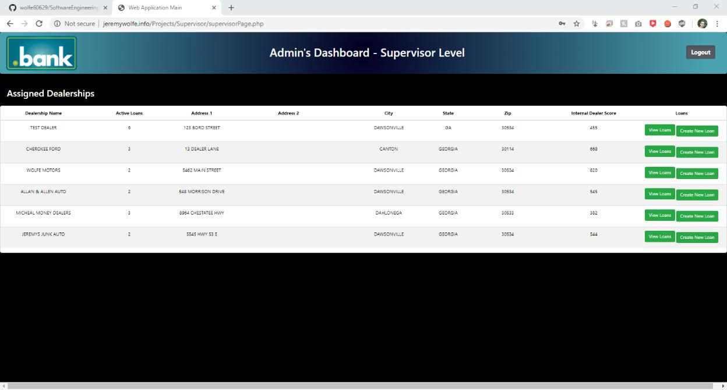This report will show all of the dealerships. It will allow the user to create a new loan for the dealership, or view existing loans. It also shows a dealer score for the dealership as well as all of the information regarding that deale

**EMPLOYEE DASHBOARD:**

This report will show the user’s assigned dealerships. It will allow the user to create a new loan for the dealership, or view existing loans. It also shows a dealer score for the dealership as well as all of the information regarding that dealer

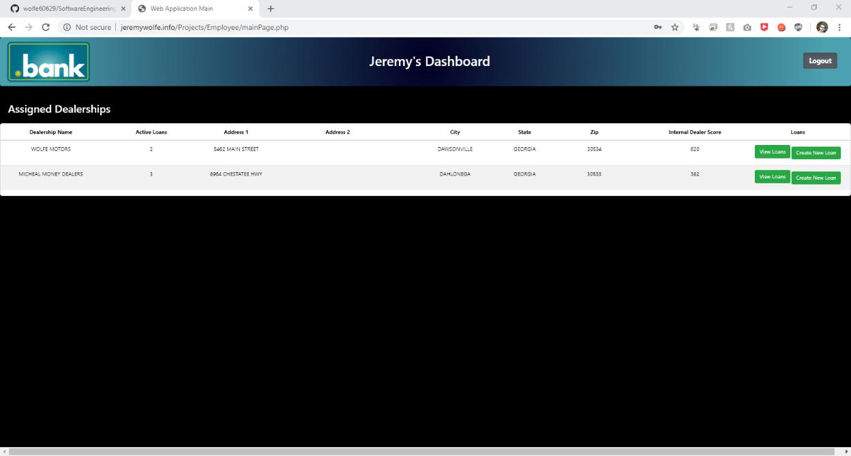

**Create Loan:**

This form will allow the user to create a loan for a particular dealership. It will ask information such as what vehicle the loan is for, and any other information that is needed for the loan.

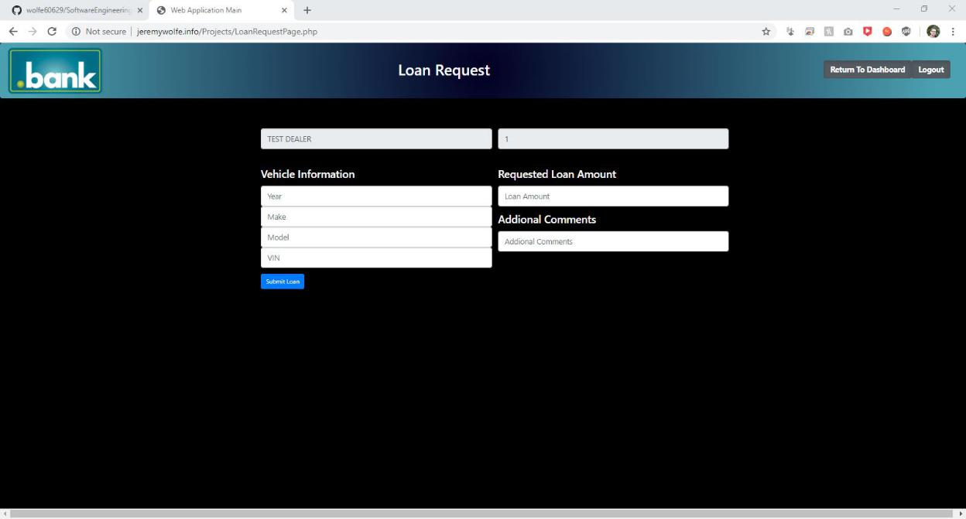

**VIEW LOAN:**

This report will show all loan information for a particular dealership.

